**User Login Guide (ITI Examination Module)**

**Annexure I**

**Introduction**

This User Login instructional guide will help the DGT, ITI’s, NSTI’s, Nodal ITI, State, Trainee and NIMI users to login to their profile.

Screenshots post Login are wrt ITI Users.

**User Login Instructions**

Please follow the instructions carefully to login to your profile

1. Click on URL: - <https://uat-iti.betalaunch.in/>
2. Click on **Login Menu** from the ITI Examination Home Page.

3. Select login type as **Admin**. In case, if you are trainee, please **select Login as a Trainee** from the radio button.

1. Please enter your **10-digit registered mobile number** with your user profile to login.
2. Trainees may need to enter their **PRN No** and **Date of Birth**.

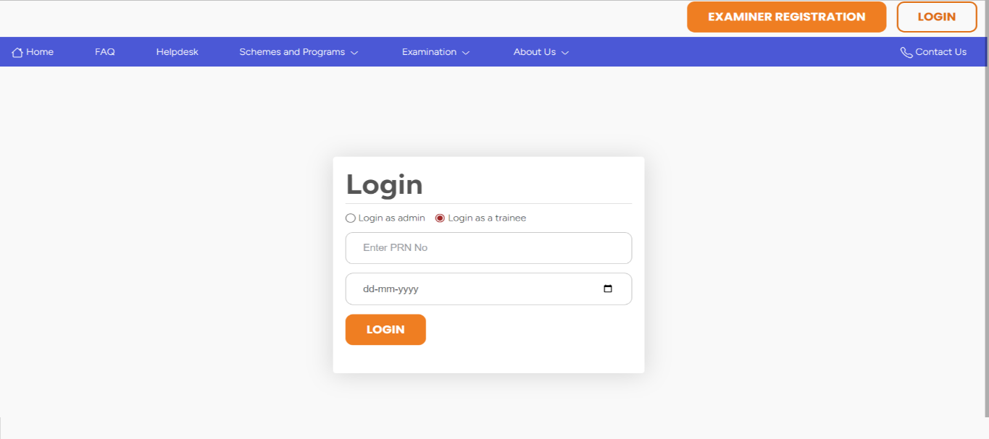

1. Once entered, click on **Login** button.
2. A screenshot of a computer

   Description automatically generatedPlease enter **123456** as default OTP. Once system is live, the User will get OTP on their 10-digit registered mobile number with their profile.
3. A screenshot of a computer

   Description automatically generatedOnce entered, you will be successfully logged in to your profile.
4. Once logged in, please cross check the profile details on the top of the right corner.

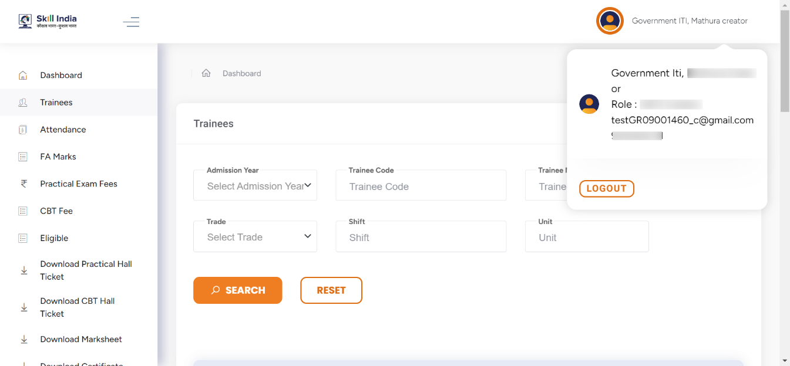

1. You may browse the different menus from the left side of the page.

**EN­D OF THE DOCUMENT**